2015-PL-01-EN Logo
0 ---- | I: ---- | II: ---- | III: medium | IV: easy

Answer Type: Multiple Choice Mandatory for: none

Body

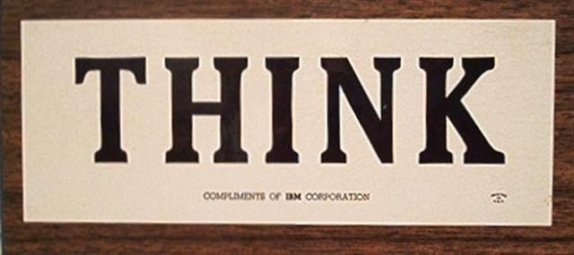

Question

The above sign has appeared on materials (plaques, banners, publications) of a certain computer company – which?

Answer

(1) ThinkCompany
(2) IBM OK
(3) Thinkpad
(4) Microsoft

Explanation

The answer is evident.

It's informatics

History of informatics is informatics.

Keywords

IBM

Websites

http://www-03.ibm.com/ibm/history/interactive/index.html

Internal Use

Wording

logo

Comments

Maciej M Syslo, syslo@ii.uni.wroc.pl, (2015-04-10), Comment.

Graphics

- Source of the logo: http://archive.poughkeepsiejournal.com/Interactive/ibm/_ibm_think.jpg
- I think, the image is public domain. If not, I can provide a photo of this logo which I have at home.

Important Note: The bottom part of the picture should be removed since it contains IBM.

Files

All additional files for this task (graphics, scripts, etc.)
2015-PL-01-EN.odt (this file)

Authorship

Maciej M. Syslo, Poland.

License

Copyright © 2014 Bebras – International Contest on Informatics and Computer Fluency. This work is licensed under a Creative Commons Attribution-NonCommercial-ShareAlike 3.0 Unported License (CC BY-NC-SA 3.0). Visit: http://creativecommons.org/licenses/by-sa-sa/3.0/

